**Problem 1:**

* Data representing a student include: name, address, mark.
* A list of students are stored in the file **students.txt** as below:

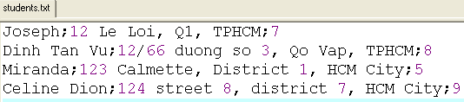

* Write a C-program that will print out the list of students in descending order based on their marks then the list will be written to the file students_2.txt with the same format as the previous file.

**Problem 2:**

Write a C-program that will sort array of int_number in descending order and print out.

Note: Use the following four different methods as follows:

* Selection_sort
* Insertion_sort
* Bubble_sort
* Quick_sort